PROJECT REPORT
COURSE CODE: 24ADI204
COURSE TITLE: DATA SCIENCE AND VISUALIZATION
PROJECT TITLE:
KIDNEYCARE ANALYTICS: EARLY DETECTION OF CHRONIC KIDNEY DISEASE USING CLINICAL HEALTH INDICATORS

SUBMITTED BY:
- GANESHKUMAR B – 25BAD025
- PRAJIT K – 25BAD080
- SAJAY SRI S – 25BAD094
- SANJAY V – 25BAD099

DEPARTMENT OF ARTIFICIAL INTELLIGENCE AND DATA SCIENCE
KUMARAGURU COLLEGE OF TECHNOLOGY
(Autonomous Institution)
COIMBATORE – 641 049

1. INTRODUCTION
The project titled "KidneyCare Analytics: Early Detection of Chronic Kidney Disease Using Clinical Health Indicators" focuses on analyzing clinical health data to identify important factors associated with Chronic Kidney Disease (CKD).
Chronic Kidney Disease is a serious health condition that affects kidney function and may remain undetected during its early stages. Early identification of possible risk indicators can help improve awareness and support healthcare decision-making.
This project uses a Chronic Kidney Disease dataset containing patient information such as age, blood pressure, blood glucose, blood urea, serum creatinine, haemoglobin, and other clinical indicators.
Data preprocessing, data cleaning, Exploratory Data Analysis (EDA), normalization, categorical encoding, feature selection, and Principal Component Analysis (PCA) are performed to understand the dataset and identify meaningful patterns.
The project aims to reduce unnecessary features, identify important clinical indicators, and generate useful insights through statistical analysis and visualization.

2. DOMAIN
Healthcare and Public Health
Healthcare data analysis plays an important role in understanding diseases, identifying health patterns, and supporting medical decision-making.
Chronic Kidney Disease affects the normal functioning of the kidneys. Clinical indicators such as blood pressure, blood glucose, serum creatinine, blood urea, and haemoglobin provide useful information about a patient's health condition.
In this project, data science techniques are applied to analyze these clinical measurements and understand their relationship with CKD classification.
The project is aligned with Sustainable Development Goal 3 – Good Health and Well-being, as it focuses on using data analysis to support better health awareness and early identification of potential health risks.

3. PROBLEM STATEMENT
Chronic Kidney Disease is a major health concern because it can develop gradually without noticeable symptoms during its early stages.
Analyzing large amounts of clinical data manually can be difficult, especially when the dataset contains missing values, inconsistent entries, and multiple numerical and categorical features.
The problem is to analyze clinical health indicators and identify meaningful patterns associated with Chronic Kidney Disease.
The dataset requires proper preprocessing, cleaning, and transformation before performing statistical analysis. Different features also have different measurement scales, which can affect further analysis.
Therefore, this project uses data cleaning, EDA, normalization, categorical encoding, feature selection, and PCA to prepare and analyze the dataset.
The main aim is to identify important clinical indicators and reduce dataset complexity while retaining meaningful information related to CKD classification.

4. PROBLEM ABSTRACT
Chronic Kidney Disease (CKD) is a serious health condition that can remain undetected until it reaches advanced stages. This project, titled "KidneyCare Analytics: Early Detection of Chronic Kidney Disease Using Clinical Health Indicators," focuses on analyzing clinical data to understand the factors associated with kidney disease.
The project uses a Chronic Kidney Disease dataset obtained from Kaggle containing 400 patient records and 26 attributes. The dataset includes clinical measurements, medical conditions, and kidney disease classification.
Initially, the dataset is examined to understand its structure, data types, missing values, and statistical characteristics. Data cleaning techniques are then applied to handle missing values, correct data types, and identify potential outliers.
Exploratory Data Analysis is performed using histograms, count plots, boxplots, and correlation heatmaps to understand the distribution and relationships between clinical variables.
Normalization, standardization, categorical encoding, and skewness transformation are applied to prepare the dataset for further analysis. Feature selection techniques are then used to identify the most relevant clinical indicators.
Finally, Principal Component Analysis (PCA) is applied to reduce dimensionality while retaining at least 90% of the variance in the selected features.
The project helps identify important patterns in clinical data and provides a structured approach to understanding factors associated with Chronic Kidney Disease.

5. OBJECTIVES
- To understand Chronic Kidney Disease using clinical health indicators.
- To explore the CKD dataset and understand its structure and attributes.
- To identify and handle missing values and inconsistent data.
- To perform data cleaning and detect potential outliers.
- To conduct Exploratory Data Analysis using appropriate visualizations.
- To analyze the relationships between clinical variables and CKD classification.
- To apply normalization and standardization to numerical features.
- To encode categorical variables into numerical formats.
- To identify and transform highly skewed numerical features.
- To perform feature selection using variance, correlation, and SelectKBest techniques.
- To apply PCA for dimensionality reduction while retaining important information.
- To generate meaningful insights from clinical health data.

6. CHALLENGES
- Missing Values: Handling missing values present in different clinical attributes.
- Data Inconsistency: Correcting unnecessary spaces, inconsistent categorical values, and incorrect data formats.
- Data Type Conversion: Converting numerical values stored as text into appropriate numerical formats.
- Outlier Detection: Identifying unusual clinical measurements using boxplots and Z-score methods.
- Data Visualization: Understanding the distribution and relationships between multiple clinical features.
- Feature Scaling: Bringing numerical variables with different measurement ranges onto a common scale.
- Categorical Encoding: Converting categorical medical information into numerical representations.
- Skewness Transformation: Identifying highly skewed numerical variables and applying suitable transformations.
- Feature Selection: Identifying important features while reducing unnecessary and redundant information.
- PCA Interpretation: Understanding principal components and selecting the appropriate number of components while retaining sufficient variance.

WEEK 1: TEAM FORMATION AND DATA HUNTING
TEAM NO : 12
TEAM MEMBERS:
- 25BAD025 – GANESHKUMAR B
- 25BAD080 – PRAJIT K
- 25BAD094 – SAJAY SRI S
- 25BAD099 – SANJAY V
PROJECT TITLE:
KidneyCare Analytics: Early Detection of Chronic Kidney Disease Using Clinical Health Indicators.
DOMAIN:
Healthcare and Public Health.
DATASET SOURCE:
Dataset Name: Chronic Kidney Disease Dataset
Platform: Kaggle
Dataset Link: https://www.kaggle.com/datasets/mansoordaku/ckdisease
ABOUT THE DATASET:
The selected dataset contains clinical measurements and medical information collected from patients. The numerical attributes include age, blood pressure, blood glucose, blood urea, serum creatinine, sodium, potassium, haemoglobin, packed cell volume, white blood cell count and red blood cell count.
The dataset also contains categorical medical attributes such as:
- Red blood cells
- Pus cells
- Pus cell clumps
- Bacteria
- Hypertension
- Diabetes mellitus
- Coronary artery disease
- Appetite
- Pedal edema
- Anemia
The classification attribute indicates whether a patient belongs to the CKD or non-CKD category.
SDG ALIGNMENT:
SDG 3 – Good Health and Well-being.
The project supports this goal by using data analysis to understand clinical indicators associated with Chronic Kidney Disease and promote data-driven healthcare awareness.

TEAM CONTRIBUTION:
TEAM MEMBERS | CONTRIBUTION
GANESH KUMAR B | Helped identify the healthcare problem, discussed possible project topics and contributed to finalizing the CKD project objectives.
PRAJIT K | Researched suitable healthcare datasets and studied the available CKD clinical attributes.
SAJAY SRI S | Maintained the GitHub repository, organized the initial project files and supported dataset collection and version management.
SANJAY V | Studied the selected dataset, reviewed its attributes and contributed to finalizing the healthcare domain and SDG alignment.

WEEK 2: KNOW YOUR DATA
OBJECTIVE
The objective of Week 2 was to understand the raw CKD dataset before performing any modifications. The team examined the structure, attributes, data types, missing values, duplicate records and statistical characteristics of the dataset.
PACKAGES USED: Pandas, NumPy, Matplotlib, Seaborn
METHODS USED:
head(), tail(), shape, columns, info(), describe(), isnull().sum(), duplicated().sum(), nunique(), dtypes
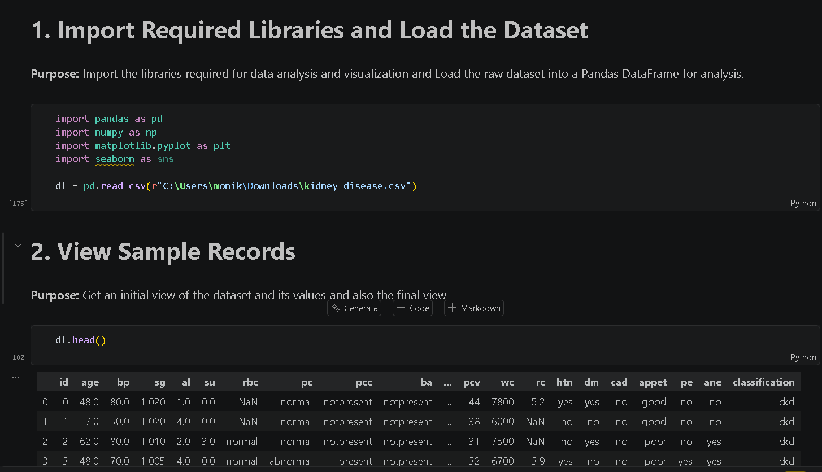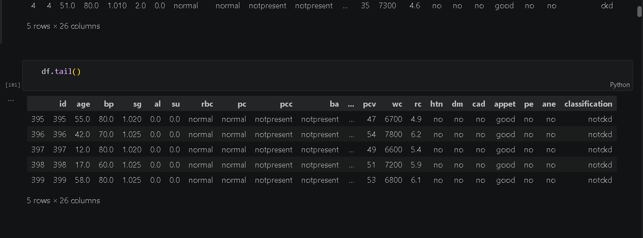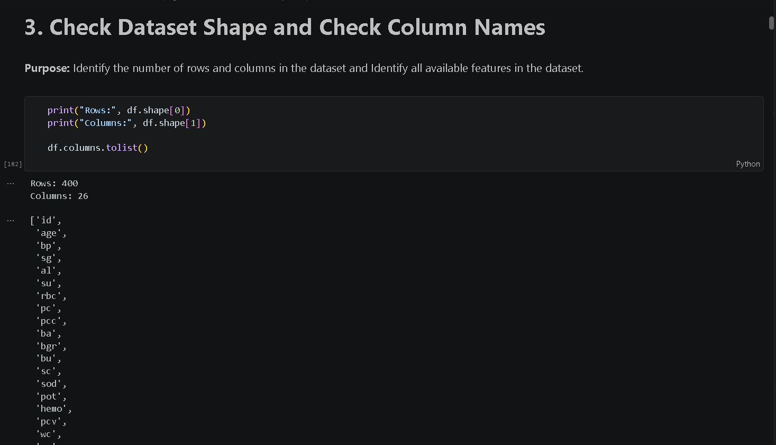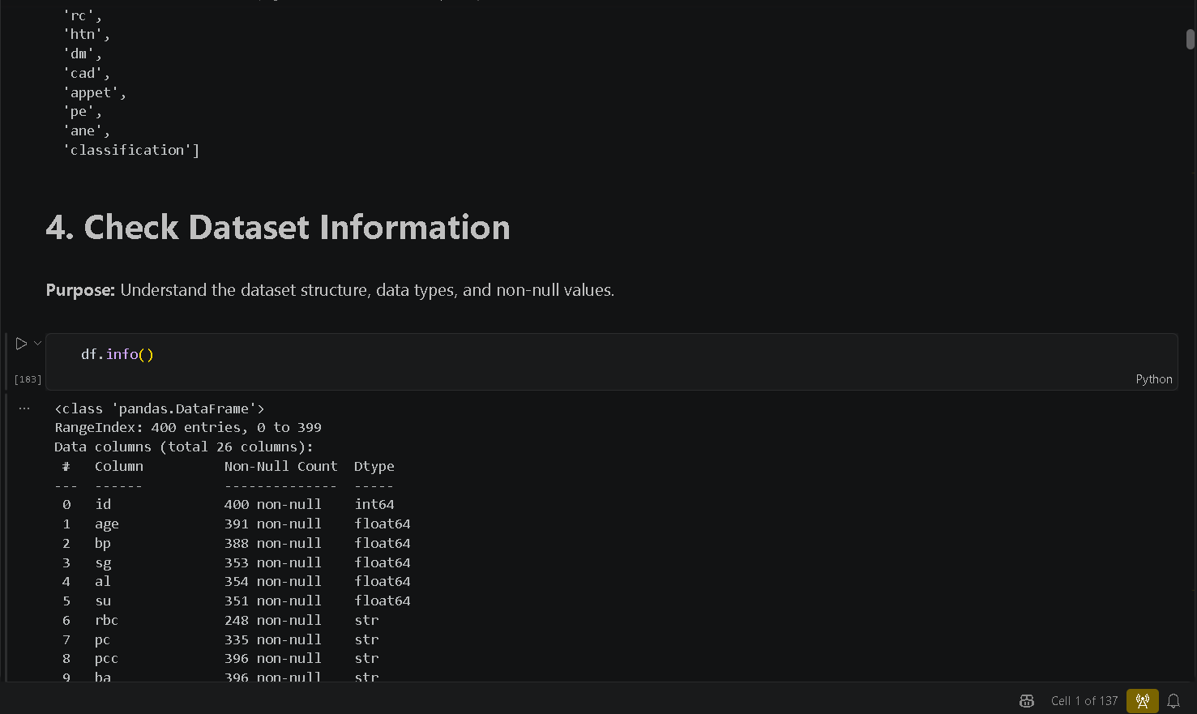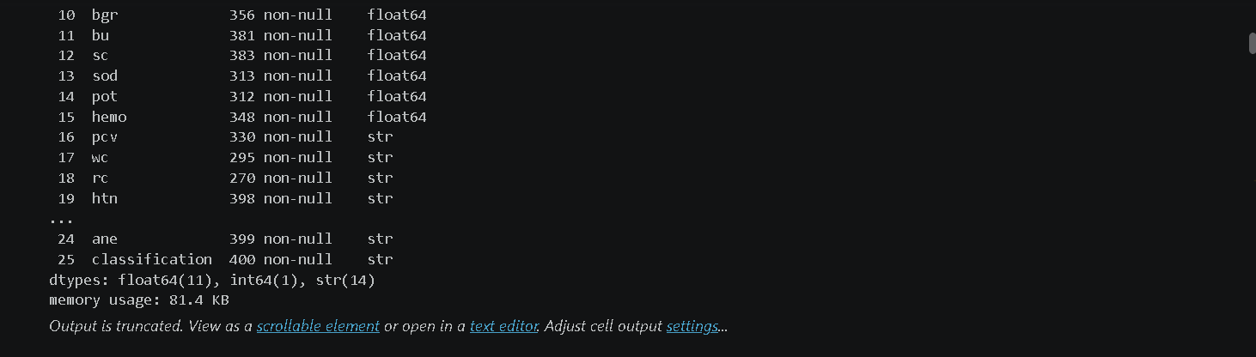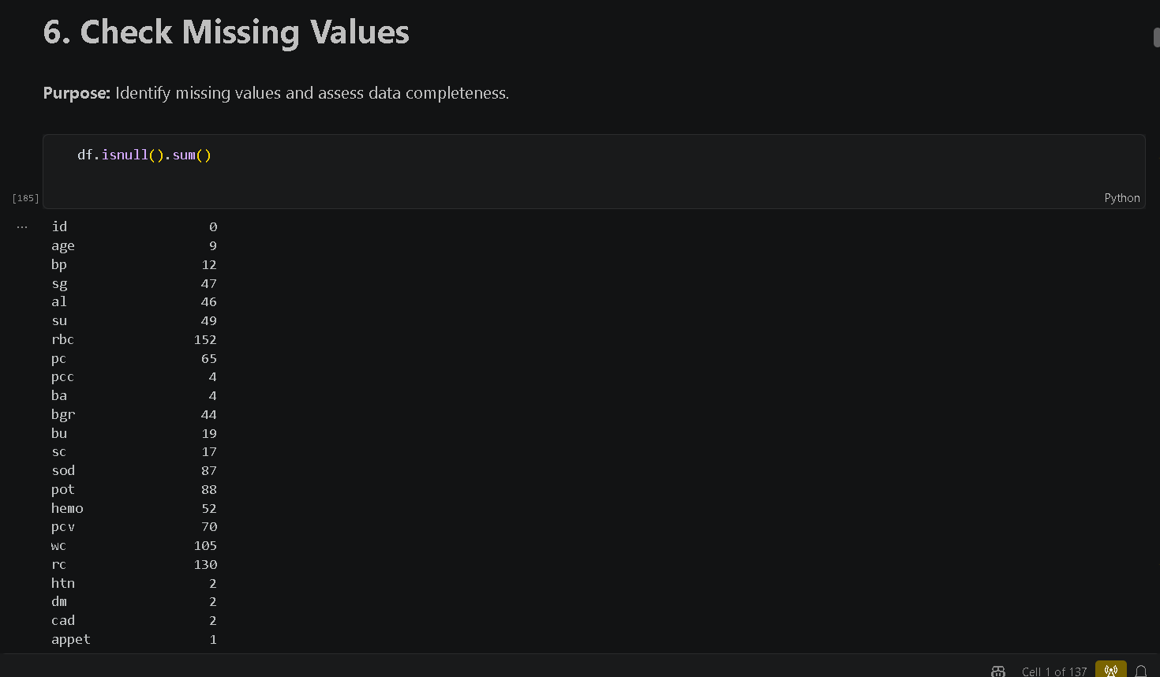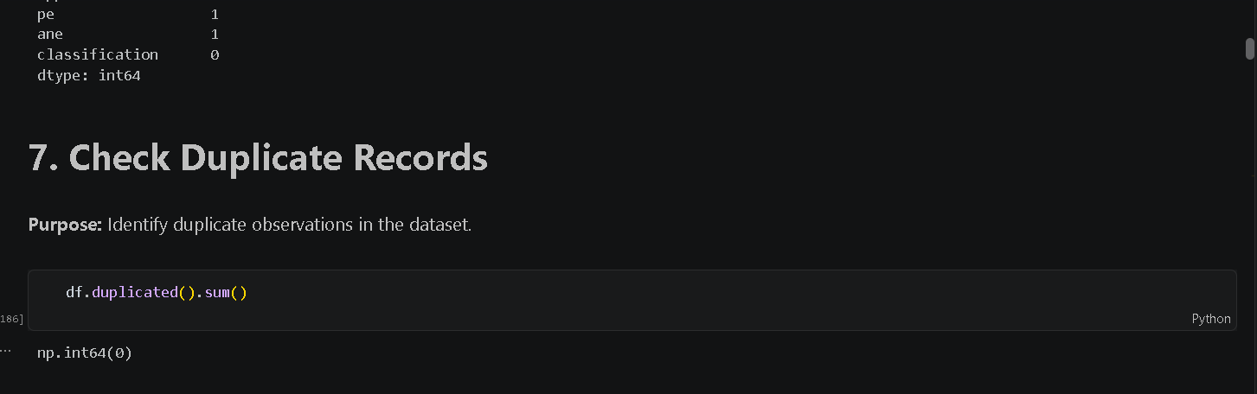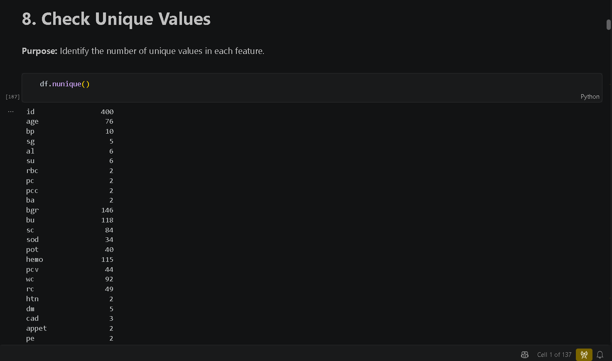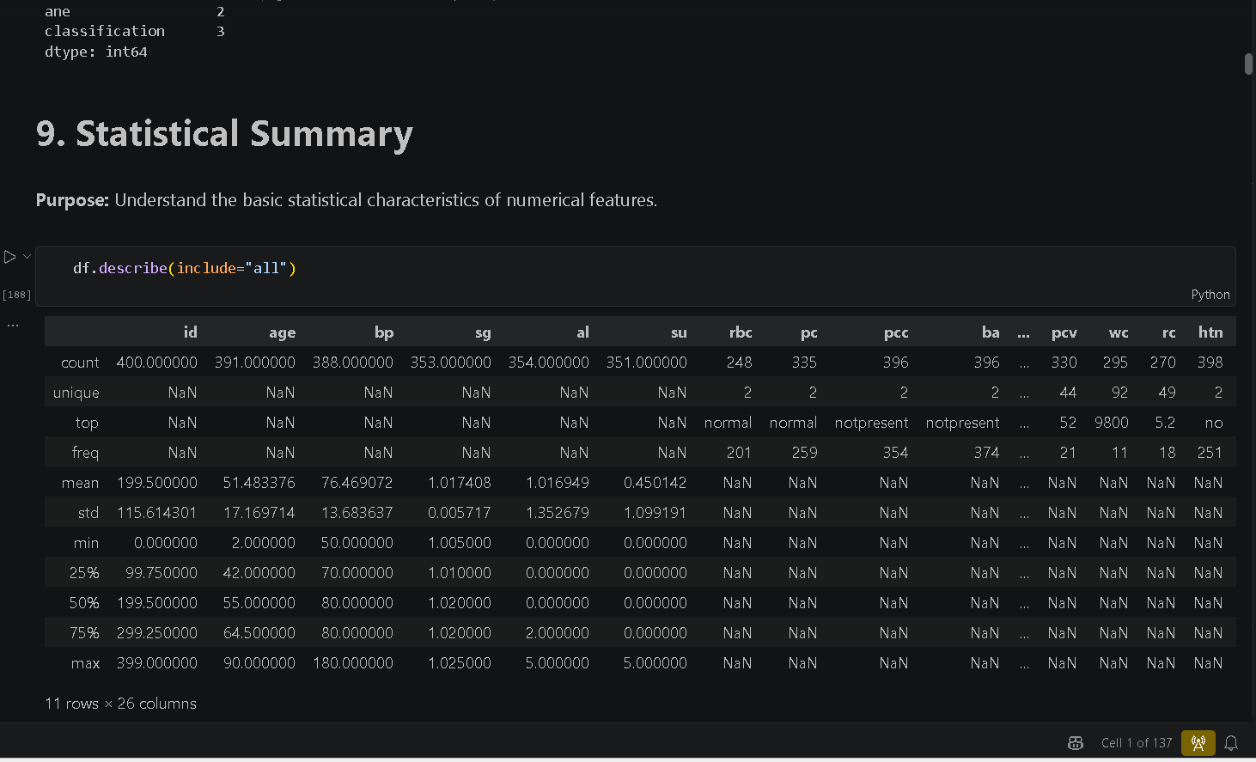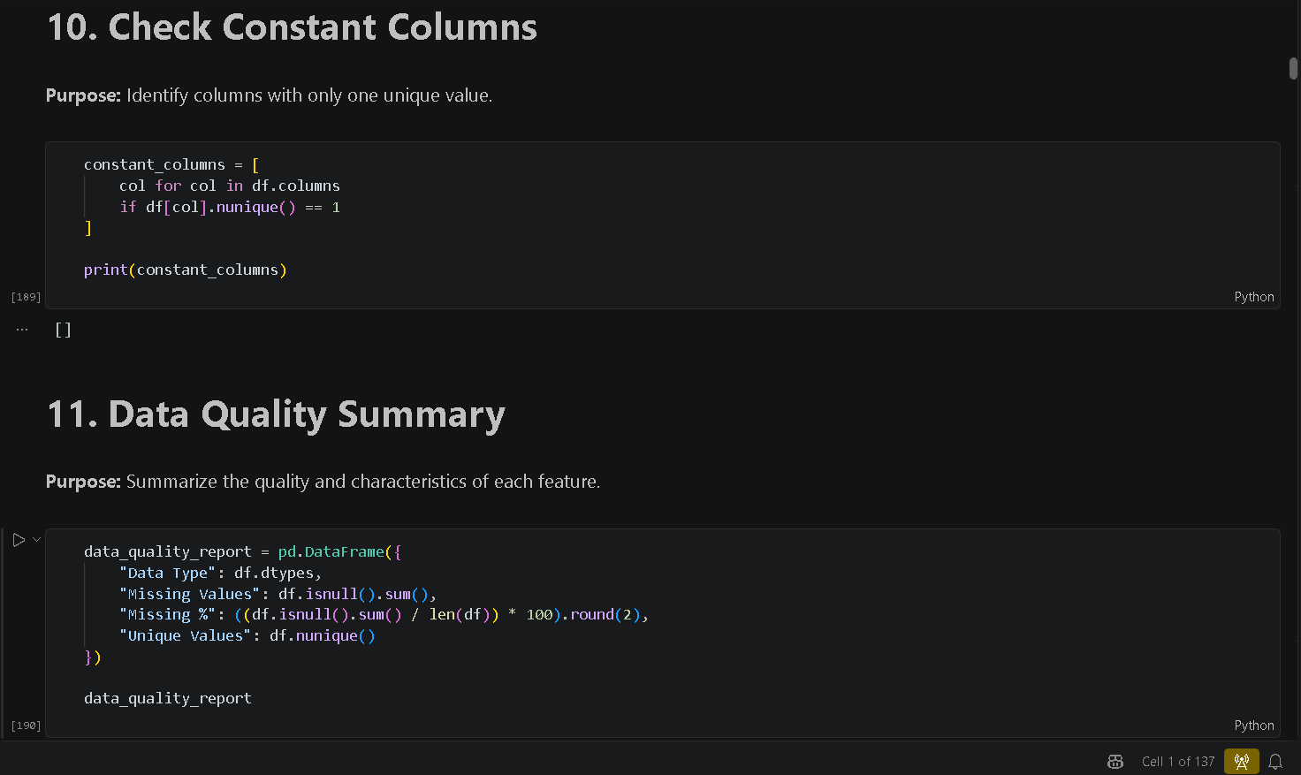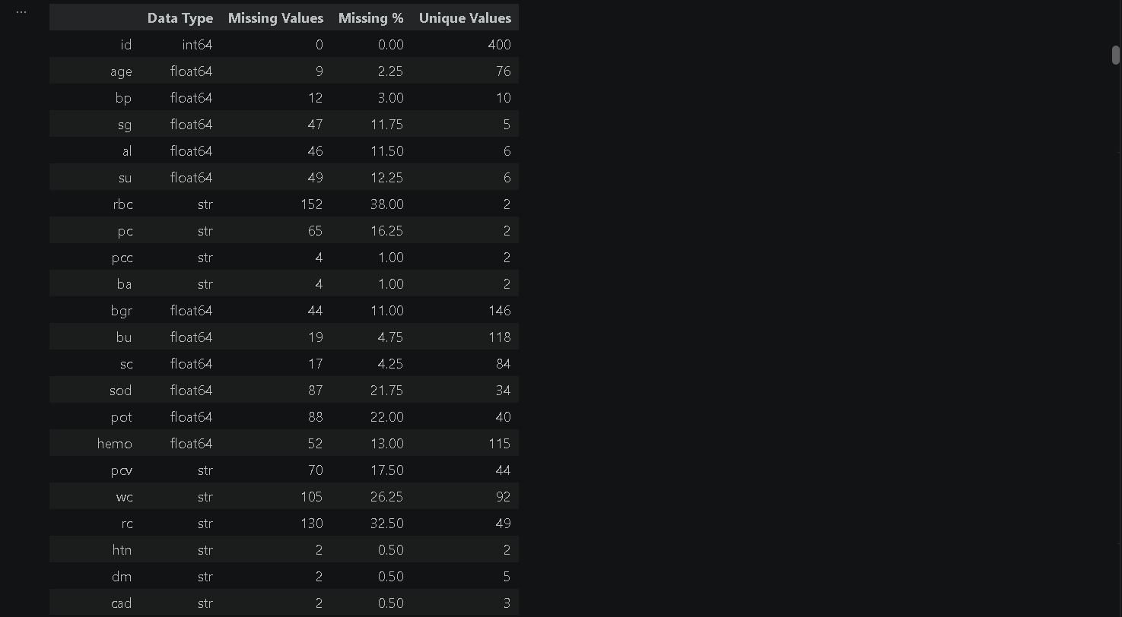

DATASET OVERVIEW:
- Total records: 400
- Total attributes: 26
- Numerical features: 12
- Categorical features: 14
- Total missing values: 1009
- Duplicate records: 0
Initial Observations:
The dataset contained a combination of numerical clinical measurements and categorical health-related information. The missing-value analysis showed that 1009 entries were missing across different attributes.
Red blood cell-related attributes had a comparatively high number of missing values, while other attributes such as white blood cell count, sodium and potassium also contained missing entries.
The statistical summary provided information about the mean, standard deviation, minimum, maximum and overall distribution of numerical variables. No duplicate records were identified.
Week 2 Outcome
The team obtained a clear understanding of the dataset and identified the major data-quality issues. These observations were used to plan the data-cleaning process in Week 3.

TEAM CONTRIBUTION:
TEAM MEMBERS | CONTRIBUTION
GANESH KUMAR B | Performed initial dataset inspection and generated statistical summaries of the numerical attributes.
PRAJIT K | Examined numerical and categorical variables and reviewed their data types and unique values.
SAJAY SRI S | Maintained GitHub, uploaded Week 2 analysis files and organized the dataset exploration work.
SANJAY V | Analyzed missing values, duplicate records and overall data-quality issues.

WEEK 3: THE CLEANING SPRINT
OBJECTIVE:
The objective of Week 3 was to clean and prepare the CKD dataset for further analysis. The major focus was on inconsistent categorical values, incorrect data types, missing values and potential outliers.
DATA CLEANING TECHNIQUES USED:
- Initial Data Quality Check
- Cleaning Categorical Values
- Data Type Conversion
- Missing Value Detection
- Numerical Missing Value Handling
- Categorical Missing Value Handling
- Missing Value Verification
- Outlier Detection Using Boxplots
- Outlier Detection Using Z-Score
METHODS USED:
- copy()
- strip()
- lower()
- pd.to_numeric()
- fillna()
- median()
- mode()
- isnull()
- boxplot()
- Z-score calculation
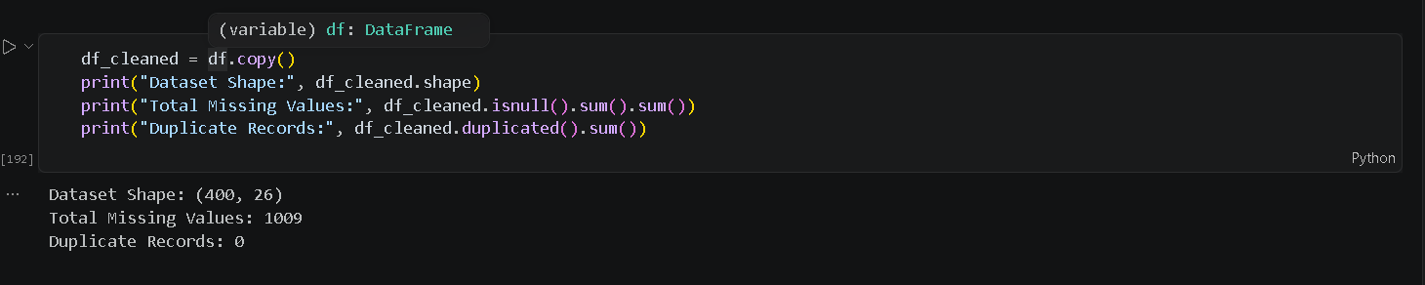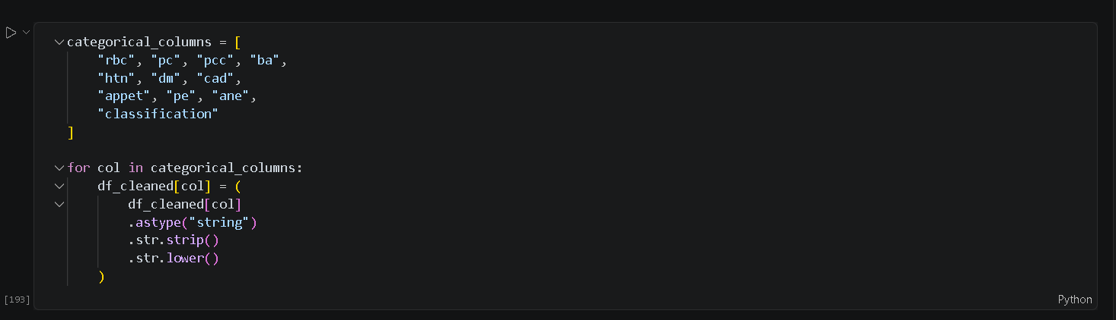
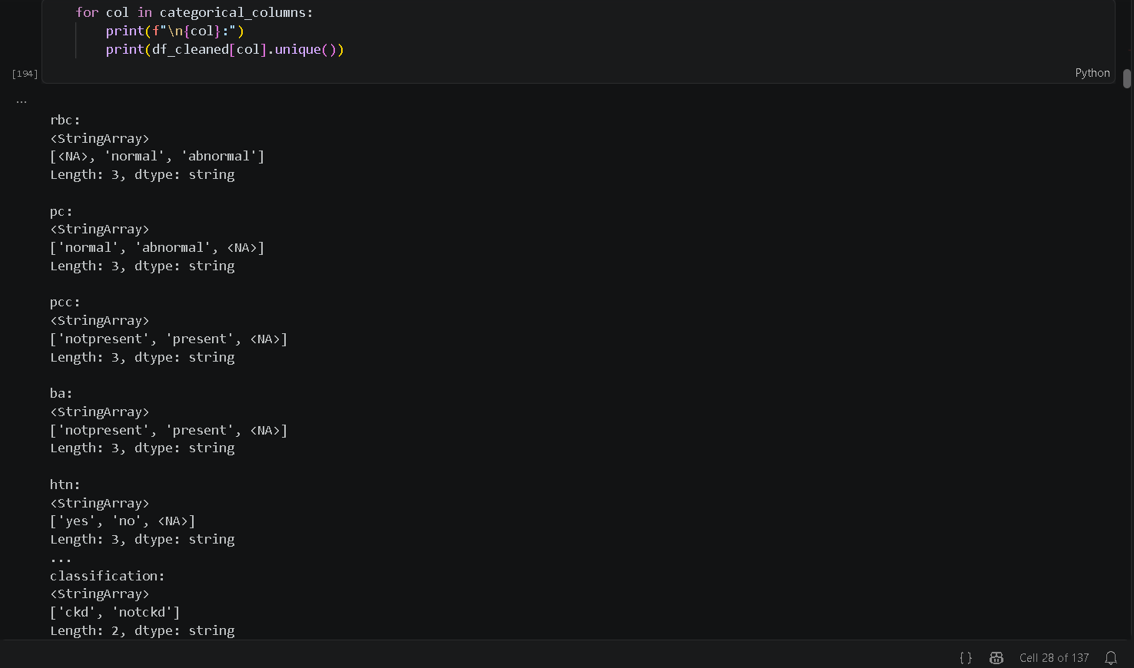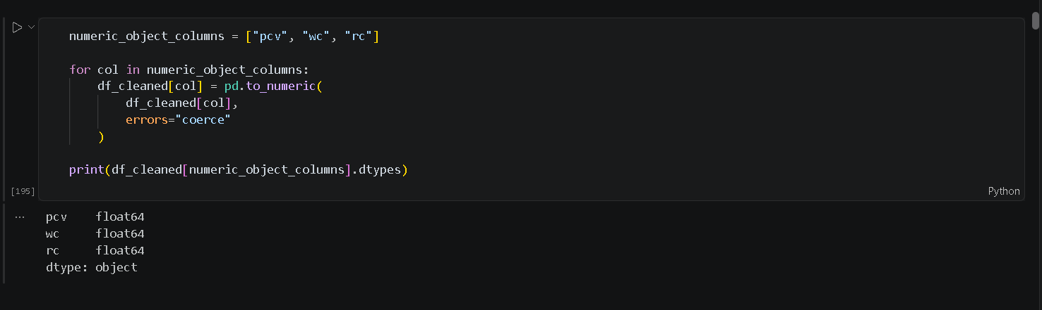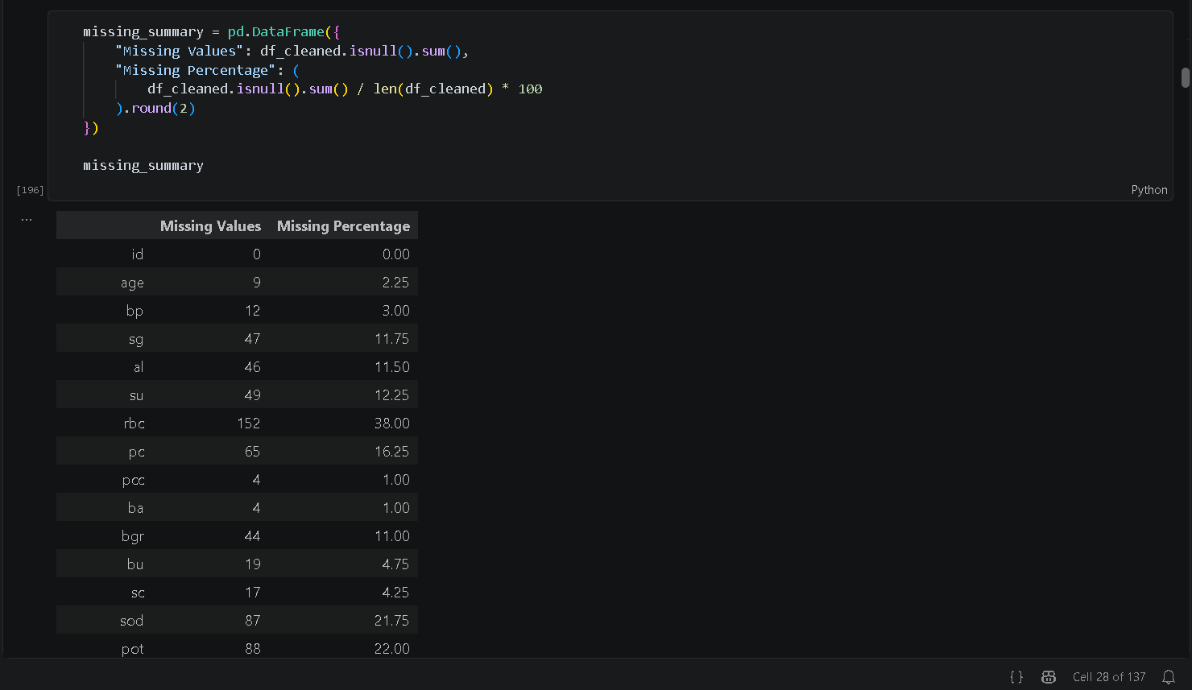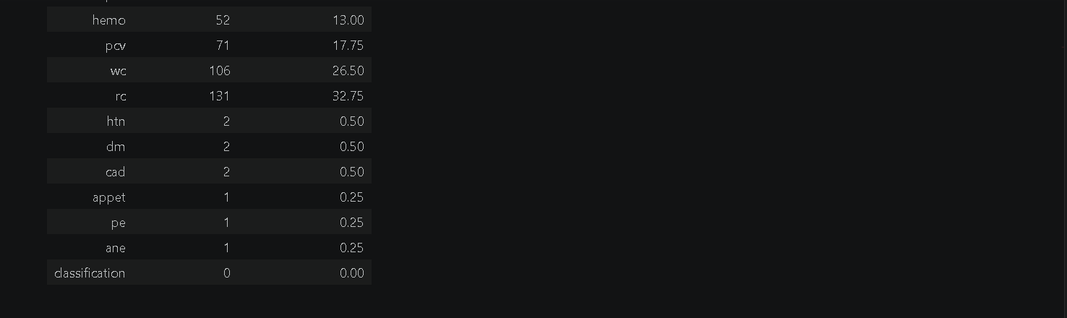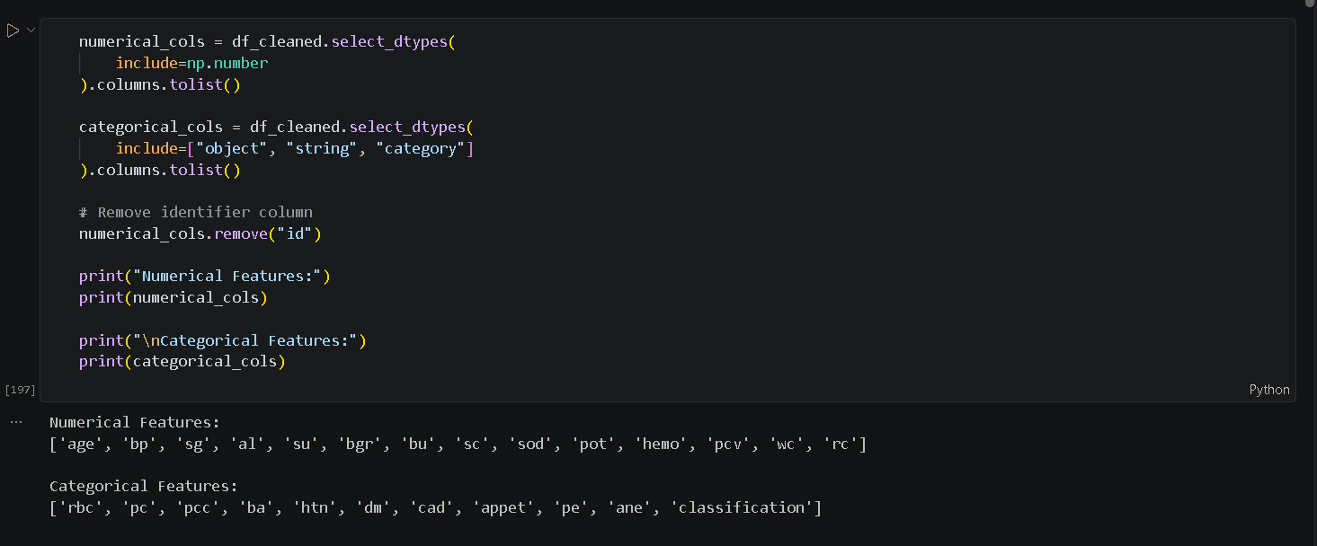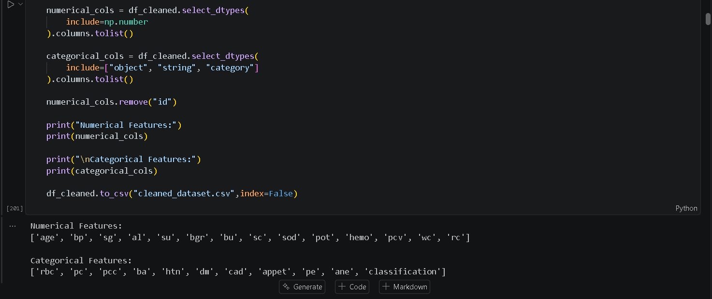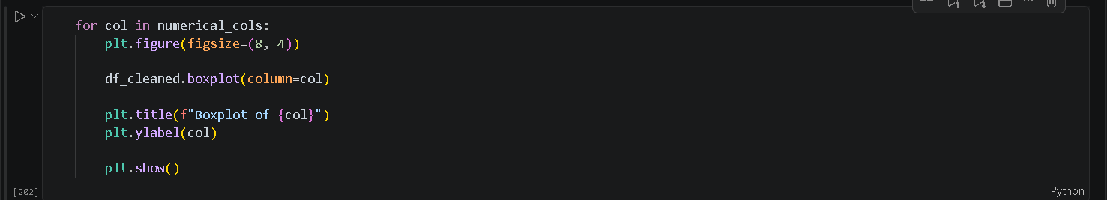

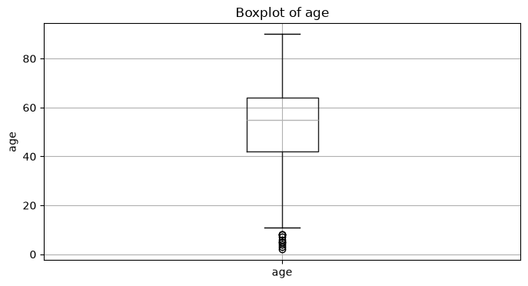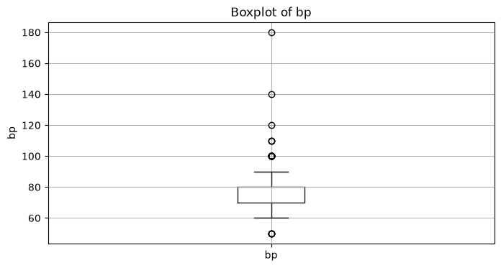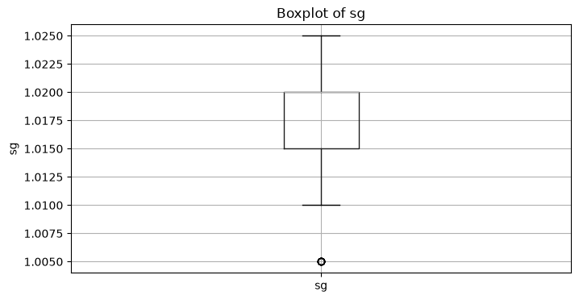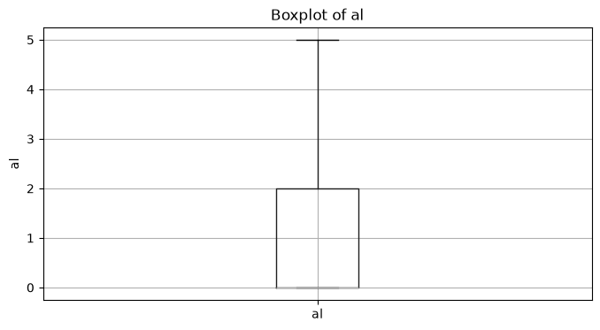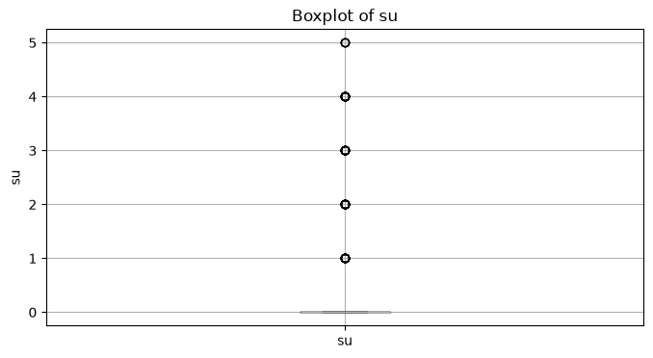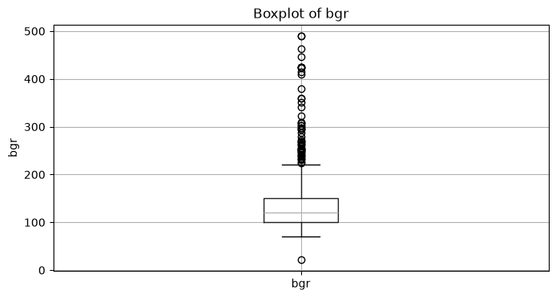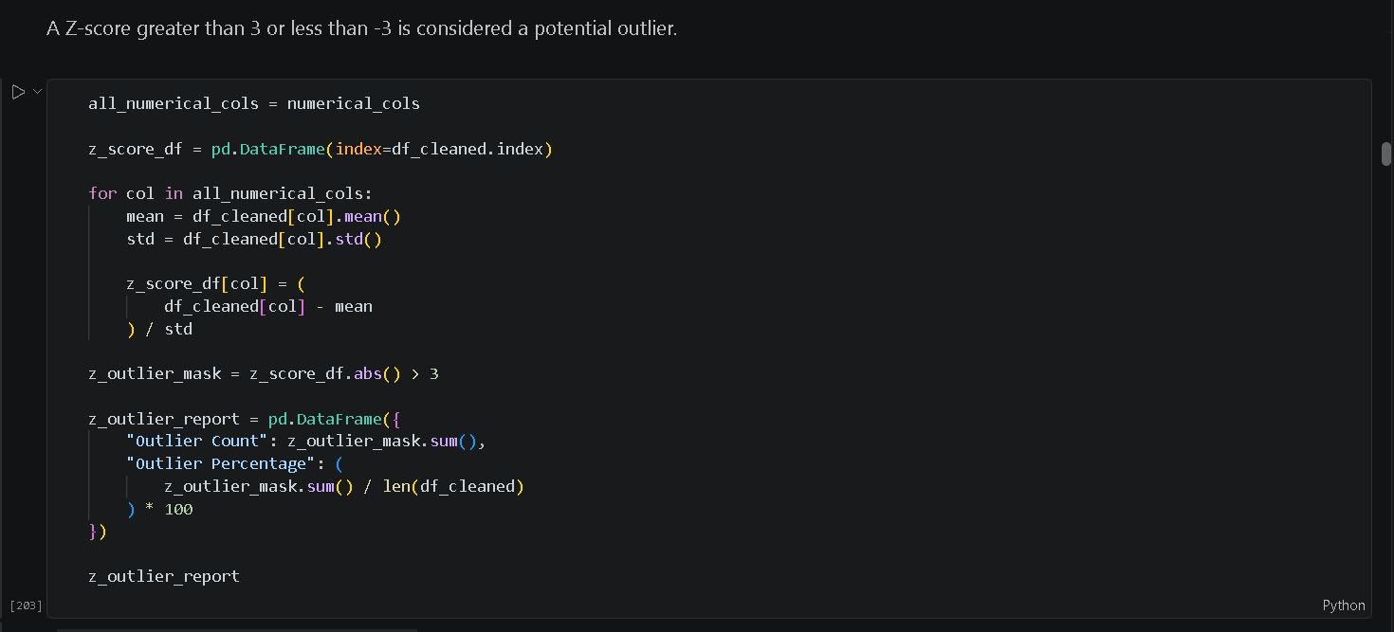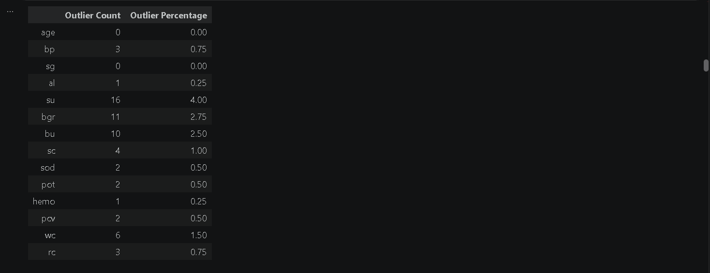
Missing-Value Treatment
Median imputation was selected for numerical features because the median is less affected by extreme values. For categorical variables, the mode was used because it represents the most frequently occurring category.
After the imputation process:
- Initial missing values: 1009
- Final missing values: 0
- Duplicate records: 0
Outlier Analysis
Boxplots were used to visually identify unusual observations. Z-score analysis was then applied, with values greater than +3 or less than −3 considered potential outliers.
Potential outliers were observed in variables including:
- Blood pressure
- Blood glucose
- Blood urea
- Blood sugar
- Other numerical clinical measurements
The cleaned dataset was saved as cleaned_dataset.csv for further analysis.
Week 3 Outcome
The raw dataset was successfully converted into a cleaned dataset with no remaining missing values. Data types and categorical inconsistencies were corrected, while potential outliers were identified for further analysis.

TEAM CONTRIBUTION:
TEAM MEMBERS | CONTRIBUTION
GANESH KUMAR B | Worked on categorical value cleaning and consistency of the dataset.
PRAJIT K | Worked on numerical data-type conversion and missing-value treatment.
SAJAY SRI S | Maintained GitHub, uploaded the cleaned-data files and organized preprocessing code and outputs.
SANJAY V | Performed boxplot and Z-score based outlier analysis and helped verify the cleaned dataset.

WEEK 4: EDA DEEP DIVE
OBJECTIVE:
The objective of Week 4 was to perform Exploratory Data Analysis (EDA) on the cleaned dataset. The analysis focused on understanding the distribution of clinical variables and identifying relationships between these variables and CKD classification.
VISUALIZATION TECHNIQUES USED:
- Target Variable Distribution
- Univariate Analysis of Numerical Features
- Univariate Analysis of Categorical Features
- Bivariate Analysis of Numerical Features vs Classification
- Bivariate Analysis of Categorical Features vs Classification
- Correlation Analysis
- Automated EDA Summary
PACKAGES USED:
- Pandas
- NumPy
- Matplotlib
- Seaborn
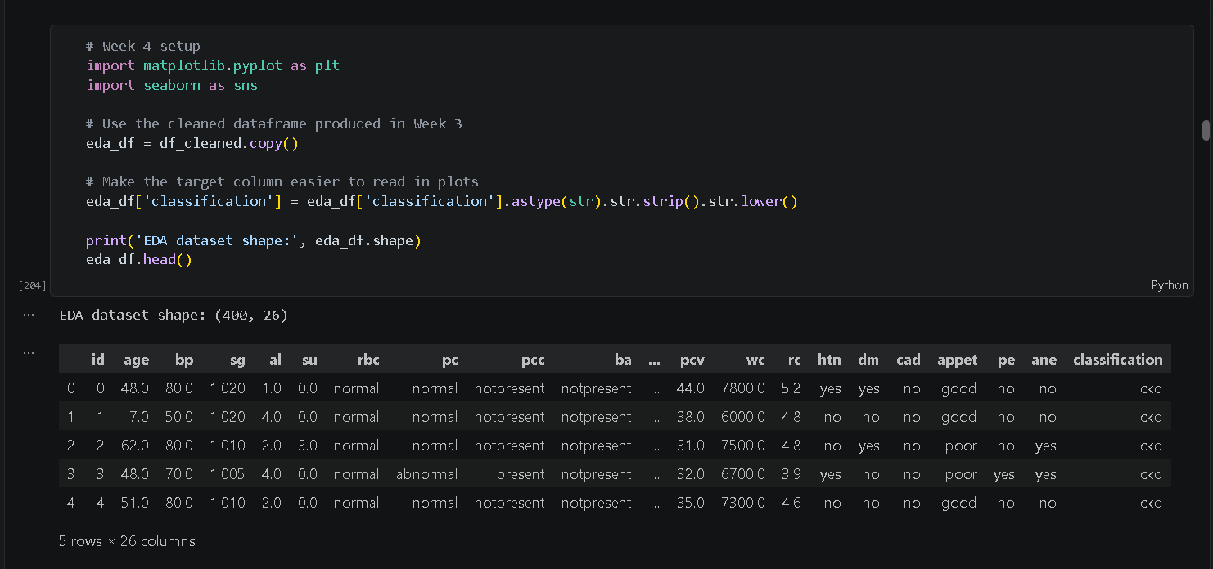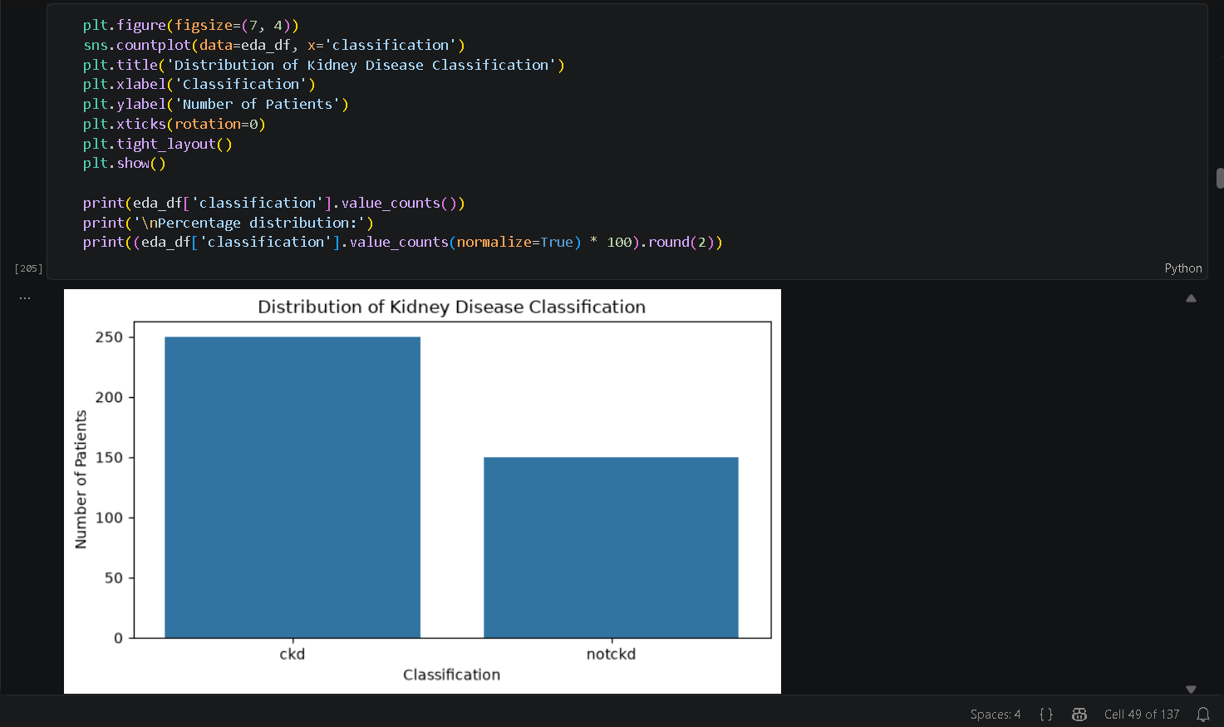
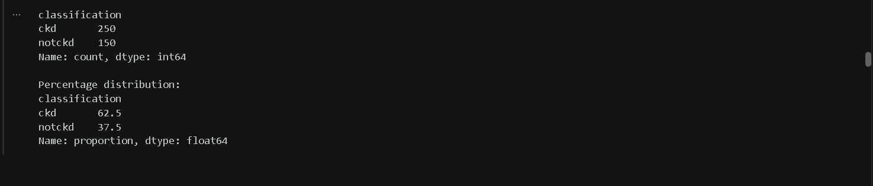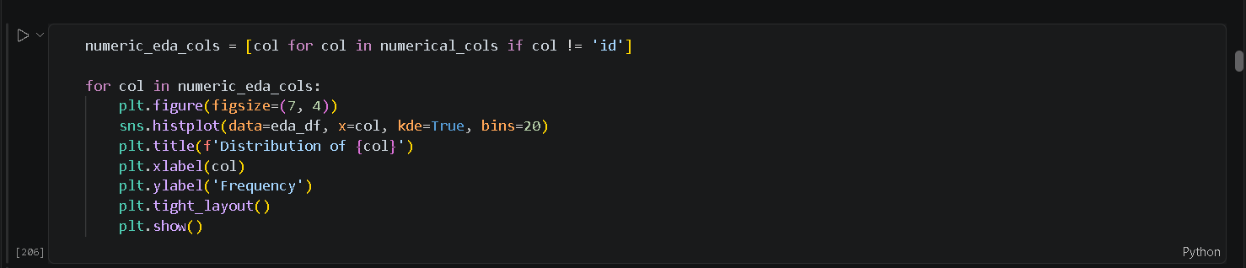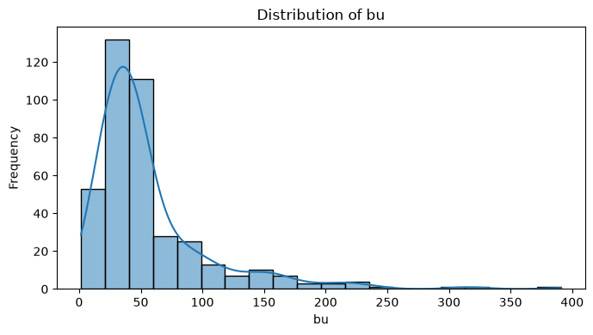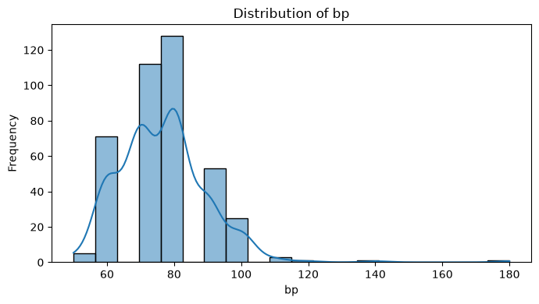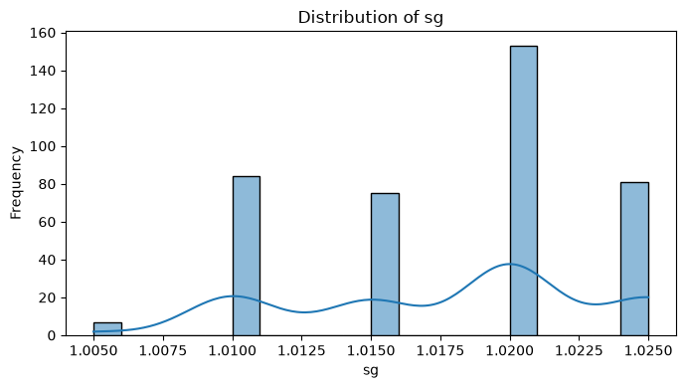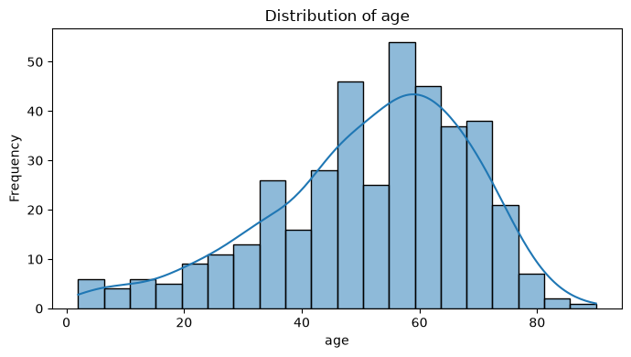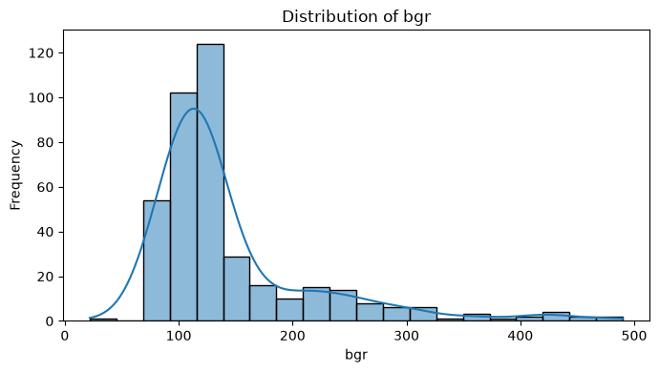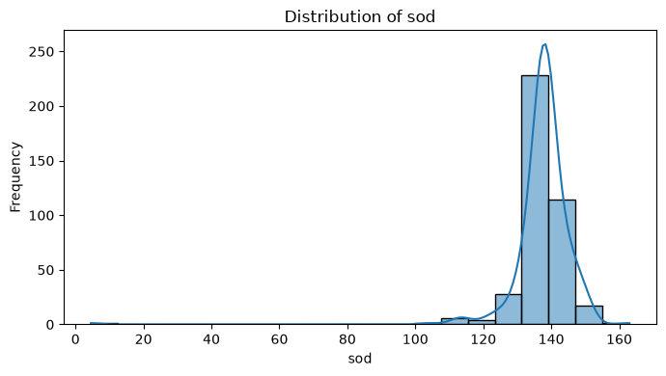

Classification Distribution
The target variable was first analyzed to understand the distribution of CKD and non-CKD patients.
- CKD: 250 patients – 62.5%
- Non-CKD: 150 patients – 37.5%
Numerical Feature Analysis
Histograms and KDE plots were used to study the distribution, spread and skewness of numerical variables such as:
- Age
- Blood pressure
- Blood glucose
- Blood urea
- Serum creatinine
- Haemoglobin
Boxplots were used to compare the distributions of clinical measurements between CKD and non-CKD patients.
Categorical Feature Analysis
Count plots and percentage-based comparisons were performed for:
- Red blood cells
- Pus cells
- Hypertension
- Diabetes
- Coronary artery disease
- Appetite
- Pedal edema
- Anemia
The analysis showed noticeable differences between the CKD and non-CKD groups. In particular, hypertension, diabetes and poor appetite showed noticeable associations with CKD classification.
Correlation Analysis
A correlation matrix and heatmap were generated to understand relationships among numerical variables. This analysis helped identify possible relationships and redundancy between features before feature selection.

An automated EDA summary was also generated to verify data types, unique values and missing-value status.
Week 4 Outcome
EDA provided a detailed understanding of the dataset and helped identify clinical variables that could be important for further analysis. The results formed the basis for normalization, feature engineering, feature selection and PCA.

TEAM CONTRIBUTION:
TEAM MEMBERS | CONTRIBUTION
GANESH KUMAR B | Performed numerical EDA using histograms, KDE plots and boxplots.
PRAJIT K | Performed categorical and bivariate analysis to study the relationship with CKD classification.
SAJAY SRI S | Maintained GitHub, organized EDA notebooks and uploaded visualization outputs.
SANJAY V | Performed correlation analysis and helped summarize the important EDA findings.

WEEK 6: NORMALIZATION, SCALING AND FEATURE ENGINEERING
OBJECTIVE:
The objective of Week 6 was to prepare the cleaned dataset for feature selection and dimensionality reduction by scaling numerical variables, encoding categorical variables and transforming highly skewed features.
PACKAGES USED:
- Pandas
- NumPy
- Matplotlib
- Seaborn
- Scikit-learn
METHODS AND TECHNIQUES USED:
- Numerical Feature Selection
- Distribution Analysis
- StandardScaler
- MinMaxScaler
- Before-and-After Scaling Comparison
- Binary Encoding
- One-Hot Encoding
- Skewness Calculation
- Yeo-Johnson Transformation
Numerical Feature Selection
The following 14 numerical features were selected:
- Age
- Blood pressure
- Specific gravity
- Albumin
- Sugar
- Blood glucose
- Blood urea
- Serum creatinine
- Sodium
- Potassium
- Haemoglobin
- Packed cell volume
- White blood cell count
- Red blood cell count
The id column was excluded because it only identifies records, while classification was treated as the target variable.
Standardization
StandardScaler was applied to the numerical features.
It transformed the features to approximately:
- Mean = 0
- Standard deviation = 1
This reduced the effect of differences in measurement scales.
Normalization
MinMaxScaler was also applied.
- Values were transformed into the range 0 to 1.
- This made numerical variables easier to compare.
- Both scaled datasets retained 400 records and 14 numerical features.
Categorical Encoding
Categorical variables were converted into numerical representations. The encoded attributes included:
- rbc
- pc
- pcc
- ba
- htn
- dm
- cad
- appet
- pe
- ane
The classification target was encoded separately.

Skewness Analysis
Skewness was calculated to identify numerical variables with highly uneven distributions. Features with absolute skewness greater than 1 were considered candidates for transformation.
The Yeo-Johnson transformation was applied to:
- bp
- al
- su
- bgr
- bu
- sc
- sod
- pot
- wc
Transformation Results
The transformation significantly improved the distribution of several variables.

Feature Before After
Potassium 13.133 -0.376
Sodium -7.929 0.101
Serum Creatinine 7.666 0.282
Blood Urea 2.724 -0.045
Blood Glucose 2.204 -0.198
WBC 2.002 0.018
These results show that the Yeo-Johnson transformation considerably reduced skewness in the selected features.
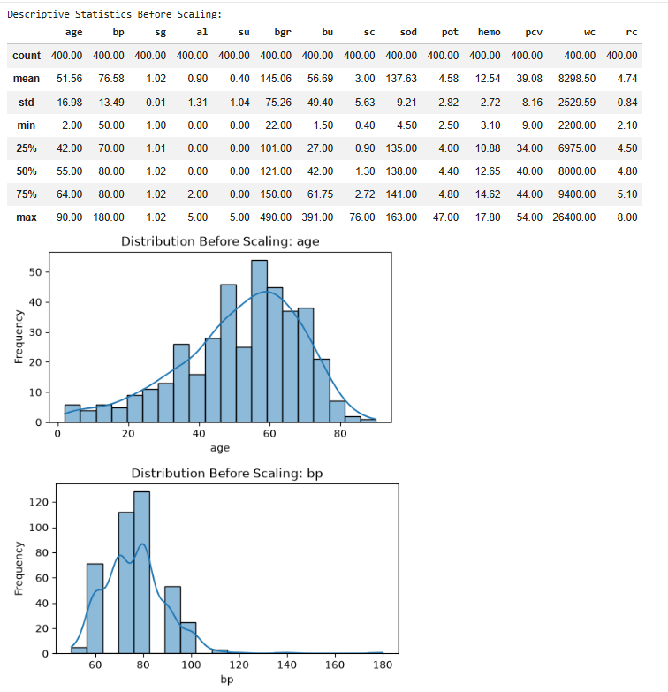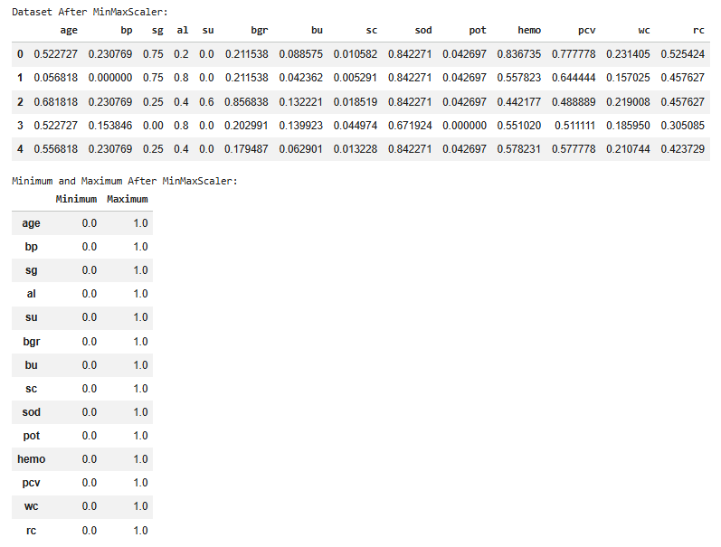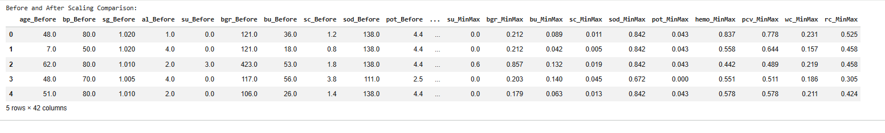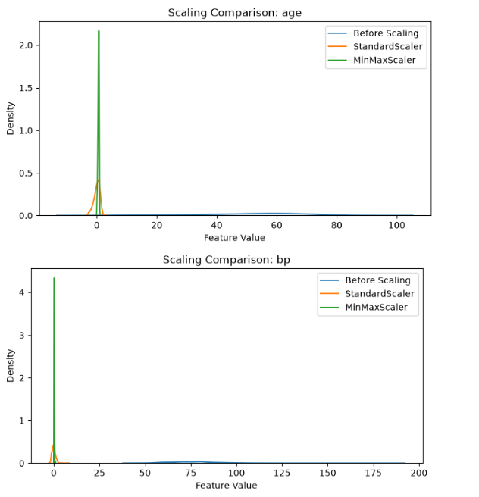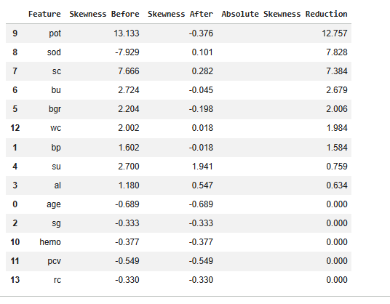

Week 6 Outcome
The numerical features were successfully scaled, categorical variables were encoded and highly skewed features were transformed. The processed datasets were prepared for feature selection and PCA.

TEAM CONTRIBUTION:
TEAM MEMBERS | CONTRIBUTION
GANESH KUMAR B | Worked on feature scaling by implementing StandardScaler and MinMaxScaler for the numerical features. He compared the scaled feature distributions and supported the organization of the Week 6 preprocessing outputs in the project repository.
PRAJIT K | Worked on categorical feature encoding using binary and one-hot encoding. He prepared the encoded features for further analysis, verified the encoded dataset structure, and organized the related preprocessing files in GitHub.
SAJAY SRI S | Assisted with categorical encoding and the preparation of transformed features. He also worked with the StandardScaler and MinMaxScaler outputs, verified the transformed dataset structure, and maintained the Week 6 datasets and preprocessing code in GitHub.
SANJAY V | Worked on analyzing feature skewness and applying the Yeo-Johnson transformation to highly skewed features. He compared feature distributions before and after transformation and maintained the transformation results and supporting files in GitHub.

WEEK 7: FEATURE SELECTION AND PRINCIPAL COMPONENT ANALYSIS (PCA)
PART A: FEATURE SELECTION
OBJECTIVE:
The objective of Week 7 was to identify the most relevant clinical indicators and reduce the dimensionality of the dataset while retaining the majority of the useful information.
The following techniques are used:
- Variance-Based Feature Selection
- Correlation-Based Feature Analysis
- Statistical Feature Selection Using SelectKBest
VARIANCE-BASED FEATURE SELECTION:
Variance-based feature selection is used to identify features that have little or no variation across patient records.
Features with zero variance contain the same value for every observation and do not provide useful information for distinguishing between patients.
The variance of each feature was calculated, and constant features were identified.
INTERPRETATION:
The analysis identified no constant features in the dataset.
- Features before selection: 24
- Features after selection: 24
- Constant features identified: 0
Therefore, all 24 input features were retained after variance analysis.
CORRELATION-BASED FEATURE ANALYSIS:
Correlation analysis was performed to understand the relationships between numerical features in the CKD dataset.
A correlation matrix and heatmap were generated to identify the strength and direction of relationships between different variables.
Feature pairs with an absolute correlation greater than 0.90 were considered highly correlated and examined for possible redundancy.
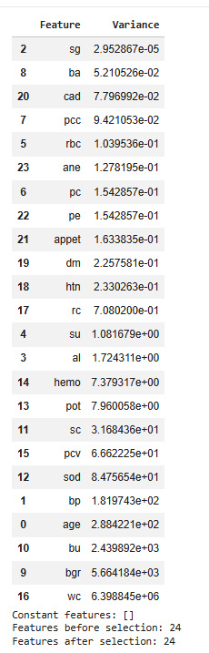
INTERPRETATION:
The correlation analysis did not identify any feature pairs exceeding the selected correlation threshold of 0.90.
Therefore, no features were removed based on correlation analysis.
STATISTICAL FEATURE SELECTION USING SELECTKBEST:
The SelectKBest technique with the ANOVA F-test was used to identify features having a strong statistical relationship with the CKD classification target.
The method calculates F-scores and ranks features based on their ability to distinguish between the target classes.
The top 10 features were selected for creating the reduced dataset.
TOP 10 SELECTED FEATURES:
- sg
- al
- bgr
- hemo
- pcv
- rc
- htn
- dm
- appet
- pe
CREATION OF REDUCED DATASET:
After completing variance analysis, correlation analysis, and SelectKBest, the selected features were used to create a reduced dataset.
Selected features:
- sg
- al
- bgr
- hemo
- pcv
- rc
- htn
- dm
- appet
- pe
Removed features:
- age
- bp
- su
- rbc
- pc
- pcc
- ba
- bu
- sc
- sod
- pot
- wc
- cad
- ane
FINAL FEATURE SELECTION OUTPUT:
- Original dataset: 400 × 26
- Reduced dataset: 400 × 11
The reduced dataset was saved as ckd_feature_selected.csv.

PART B: PRINCIPAL COMPONENT ANALYSIS (PCA)
OBJECTIVE:
PCA was applied to the selected features after standardization. The purpose was to reduce the number of dimensions while preserving as much information as possible.
In this project, PCA is applied to the selected features after standardization. The number of principal components is selected based on the cumulative explained variance, with a target of retaining at least 90% of the total variance.
LOAD THE SELECTED FEATURES:
The feature-selected dataset created in the previous section was used as the input for PCA.
The classification column was separated from the input features because it represents the target variable and should not be included in the PCA calculation.
- Total records: 400
- Selected input features: 10
- Target variable: classification
STANDARDIZATION OF SELECTED FEATURES:
Before applying PCA, the selected features were standardized using StandardScaler.
This step ensures that all selected features have approximately zero mean and unit standard deviation.
Standardization prevents features with larger numerical ranges from dominating the principal components.
APPLY PRINCIPAL COMPONENT ANALYSIS:
PCA was applied to the standardized dataset to transform the 10 selected features into 10 principal components.
Each principal component represents a combination of the original features and captures a portion of the total variance in the dataset.
EXPLAINED VARIANCE ANALYSIS:
Explained variance measures the amount of information captured by each principal component.
The results obtained from the notebook are shown below.
Principal Component | Explained Variance
PC1 | 47.51%
PC2 | 11.08%
PC3 | 9.19%
PC4 | 8.26%
PC5 | 6.22%
PC6 | 5.00%
PC7 | 4.31%
PC8 | 3.65%
PC9 | 3.29%
PC10 | 1.50%
CUMULATIVE EXPLAINED VARIANCE:
Cumulative explained variance was calculated to determine how much total information is retained when multiple principal components are combined.
The cumulative variance increases as more principal components are included.
The first seven principal components retain approximately 91.55% of the total variance.
SELECTING THE NUMBER OF PRINCIPAL COMPONENTS:
The minimum number of principal components required to retain at least 90% of the total variance was selected.
- Total selected components: 7
- Total available components: 10
- Cumulative variance retained: 91.55%
Therefore, seven principal components were selected for the final reduced dataset.
CREATION OF REDUCED PCA DATASET:
After selecting seven principal components, the original selected features were transformed into a reduced representation.
The original classification target was added back to the transformed dataset.
The final dataset contains:
- PC1
- PC2
- PC3
- PC4
- PC5
- PC6
- PC7
- classification
FINAL PCA DATASET SHAPE:
- Original selected features: 10
- Principal components retained: 7
- Target variable: 1
- Total columns: 8
- Total records: 400
SAVE THE PCA DATASET:
The final PCA dataset was saved as a CSV file for future analysis and machine learning applications.
The PCA variance report was also saved to document the explained variance of each principal component.
PCA VISUALIZATION:
A two-dimensional visualization was generated using the first two principal components, PC1 and PC2.
The classification labels were represented using different colors to observe the distribution of CKD and non-CKD patients in the reduced feature space.
This visualization provides a simplified representation of the selected clinical features and helps understand the distribution of the two classes after dimensionality reduction.

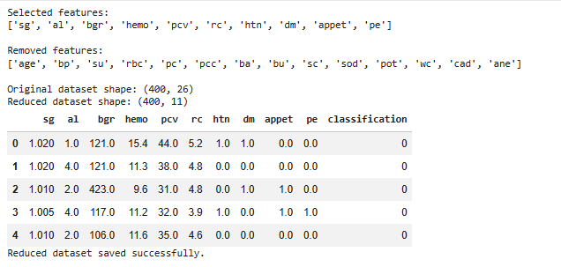
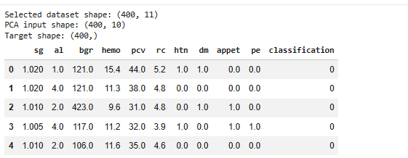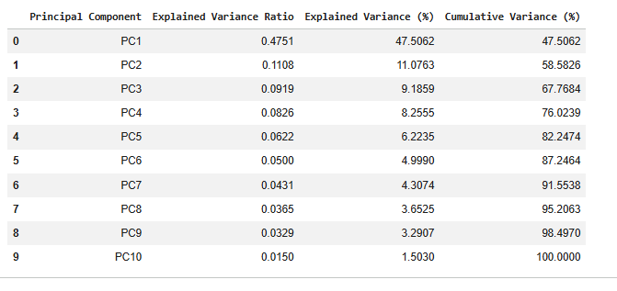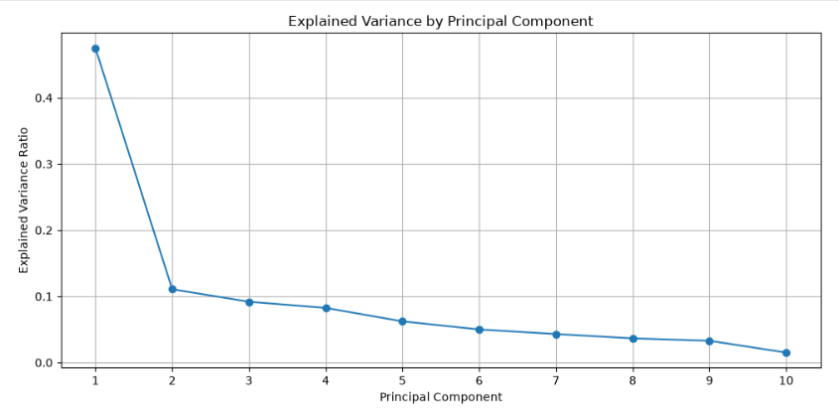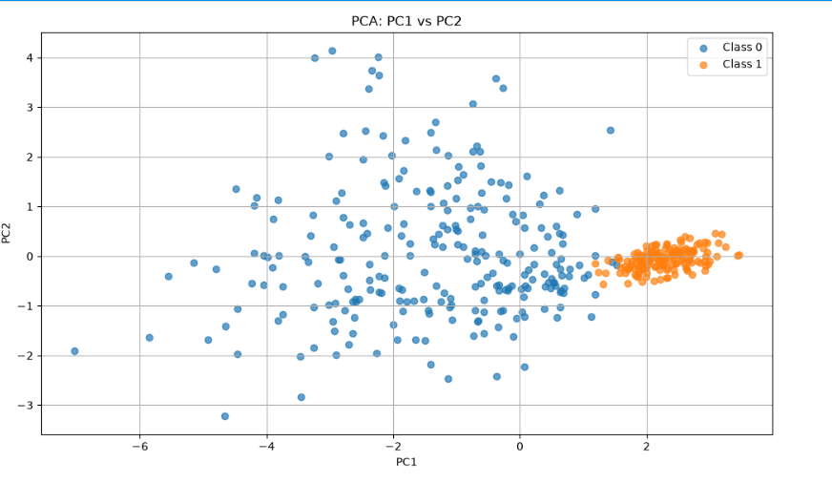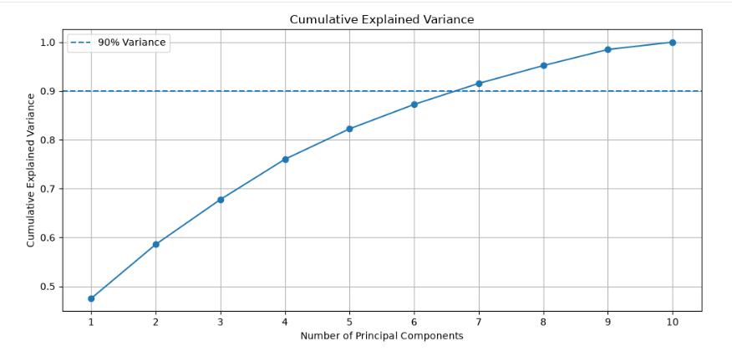
Week 7 Outcome
Feature selection reduced the original information to 10 important clinical indicators. PCA further reduced these 10 features to 7 principal components while retaining 91.55% of the total variance. The final reduced dataset was saved for future machine-learning and predictive analysis.

TEAM CONTRIBUTION:
TEAM MEMBERS | CONTRIBUTION
GANESH KUMAR B | Worked on variance-based and correlation-based feature analysis to identify relevant features for dimensionality reduction. He analyzed relationships between features and contributed to organizing the feature-analysis results in GitHub.
PRAJIT K | Worked on SelectKBest feature selection and identified the top 10 important features: sg, al, bgr, hemo, pcv, rc, htn, dm, appet, and pe. He prepared the selected-feature dataset and organized the related files in GitHub.
SAJAY SRI S | Assisted with feature selection and preparation of the selected-feature dataset for PCA. He also contributed to the PCA implementation and organization of the principal-component outputs while maintaining the related notebooks, datasets, and project files in GitHub.
SANJAY V | Worked on PCA implementation and analyzed the explained variance and cumulative explained variance results. He also analyzed the PC1 versus PC2 visualization and verified that seven principal components retained 91.55% cumulative variance, while maintaining the PCA results in GitHub.

WEEK 8: DASHBOARD DEVELOPMENT AND VISUAL STORYTELLING
Objective
The objective of Week 8 was to transform the results obtained from the previous weeks into an interactive Power BI dashboard. The dashboard provides a visual and user-friendly representation of the major CKD patterns identified during the analysis.
Instead of presenting the analysis only through tables and statistical outputs, the dashboard allows users to interact with the data and explore different clinical and patient-related patterns.
Dashboard Sections
1. CKD Overview
This section provides an overall summary of the dataset and CKD classification.
It presents:
- CKD vs non-CKD distribution
- Patient counts
- Overall classification patterns
- Age-related distribution
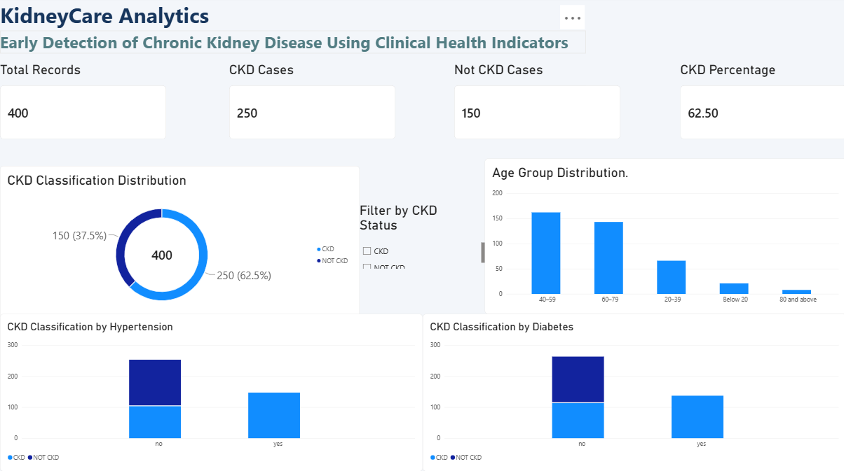
- Summary-level visualizations

2. Clinical Indicators
This section focuses on the major clinical measurements analyzed during the project.
The visualizations help compare clinical indicators between CKD and non-CKD groups and understand how these measurements vary across patients.
Key areas include:
- Clinical measurements
- Classification-based comparisons
- Age-group analysis
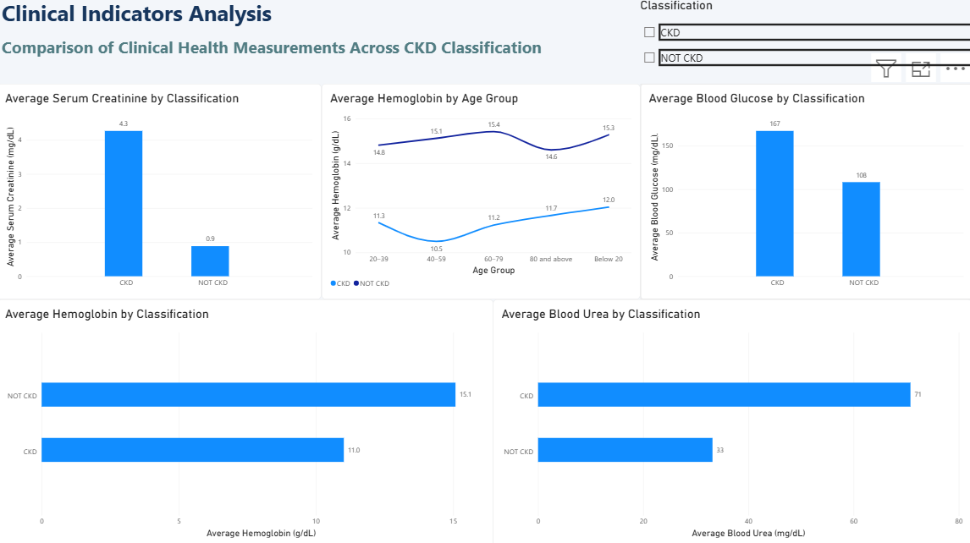
- Interactive filtering

3. Patient Risk Factors & Health Profile
This section focuses on patient characteristics and health conditions associated with CKD.
It includes analysis of:
- Patient profiles
- Health conditions
- Risk factors
- Classification patterns
- Comparative visualizations

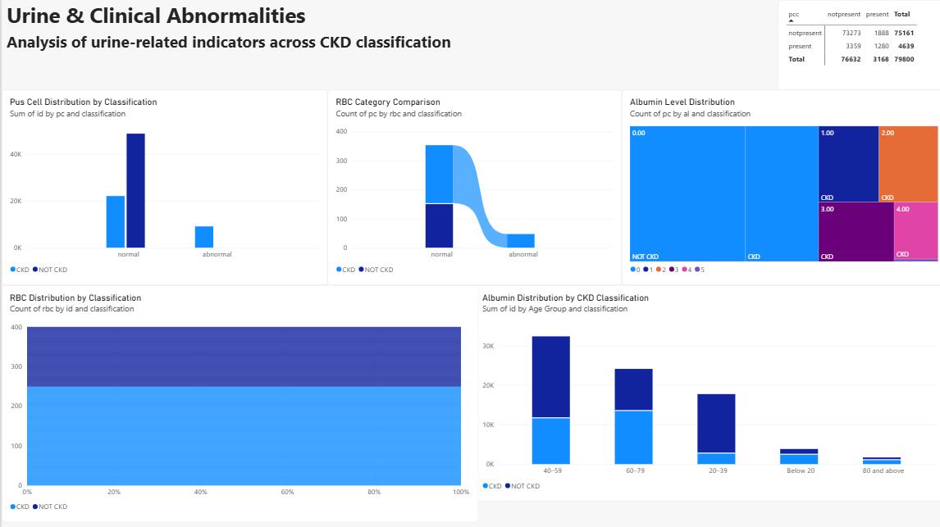

4. Urine & Clinical Abnormalities
This section focuses on categorical clinical indicators and abnormalities observed in the dataset.
It includes:
- Red blood cell analysis
- Pus cell analysis
- Urine-related indicators
- Other clinical abnormalities
- CKD/non-CKD comparisons
Dashboard Interactivity
The Power BI dashboard provides interactive features such as:
- Classification filters
- Slicers
- Cross-filtering
- Interactive charts
- Comparative visualizations
- Category-based exploration
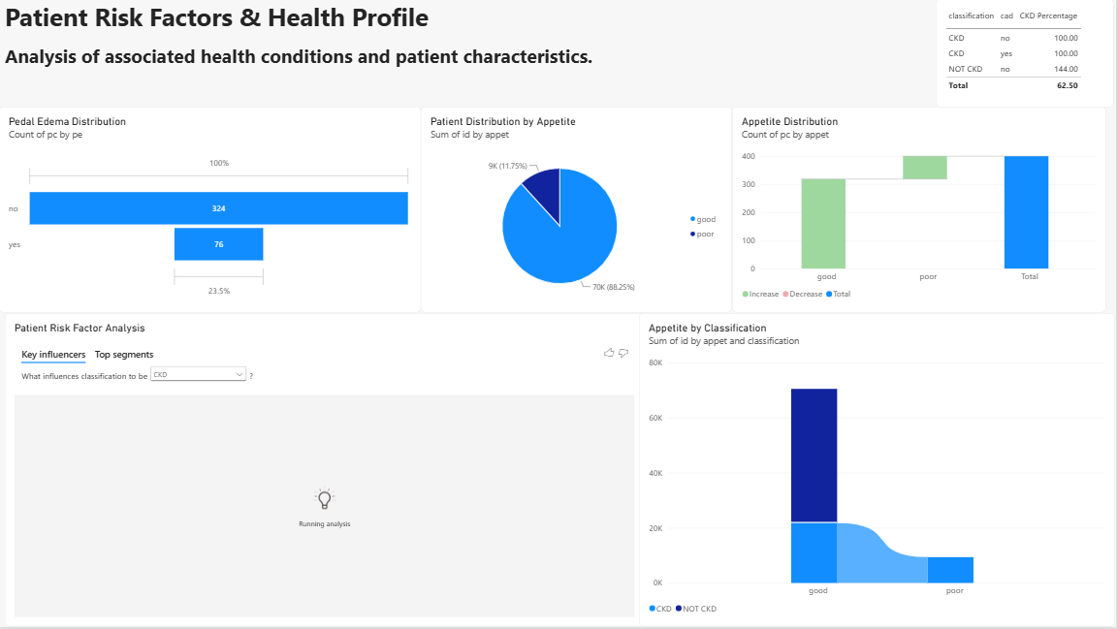
These features allow users to explore the dataset from different perspectives rather than viewing static charts.

Dashboard Outcome
The final dashboard brings together the major findings from the data-cleaning, EDA, feature-engineering and feature-selection stages. It provides a visual summary of CKD-related patterns and makes the project findings easier to communicate.

TEAM CONTRIBUTION:
TEAM MEMBERS | CONTRIBUTION
GANESH KUMAR B | Worked on the overall Power BI dashboard layout and contributed to the CKD Overview page. He helped organize important project KPIs and clinical visuals and maintained the final dashboard-related project files in GitHub.
PRAJIT K | Worked on the Clinical Indicators and Patient Risk Factors & Health Profile sections of the Power BI dashboard. He helped organize the relevant clinical variables and visual elements and maintained the dashboard updates in GitHub.
SAJAY SRI S | Assisted in developing and organizing the Power BI dashboard pages and integrating the analytical outputs into the final dashboard. He also contributed to arranging clinical and patient-related visuals while maintaining the final dashboard files and project documentation in GitHub.
SANJAY V | Worked on the Urine & Clinical Abnormalities section of the Power BI dashboard and assisted with visual selection and dashboard storytelling. He helped integrate the analytical findings into the dashboard, supported the final review, and maintained the completed project files in GitHub.

8. REFERENCES
- Chronic Kidney Disease Dataset – Kaggle: https://www.kaggle.com/datasets/mansoordaku/ckdisease
- Pandas Documentation: https://pandas.pydata.org/docs/
- NumPy Documentation: https://numpy.org/doc/
- Matplotlib Documentation: https://matplotlib.org/stable/
- Seaborn Documentation: https://seaborn.pydata.org/
- Scikit-learn Documentation: https://scikit-learn.org/stable/

